MINI PROJECT REPORT
on
"On Road Vehicle Breakdown Assistance System"
By
Abhishek Shinde 119A3003
Prajyot Bhoir 119A3011
Dhanvi Mange 119A3013
UNDER THE GUIDANCE OF
Prof. - Seema Redekar

SUBMITTED IN PARTIAL FULFILLMENT FOR THE DEGREE OF
BACHELOR OF ENGINEERING

In
Information Technology

DEPARTMENT OF INFORMATION AND TECHNOLOGY
SIES GRADUATE SCHOOL OF TECHNOLOGY
NERUL, NAVI MUMBAI – 400706
ACADEMIC YEAR
2020– 2021

CERTIFICATE
This is to certify that this is a bonafide record of Mini Project of the project titled “On Road Vehicle Breakdown Assistance System” carried out by the following students of second year in Information Technology.
Sr. No. Name Roll No.
1. Abhishek Shinde 119A3003
2. Prajyot Bhoir 119A3011
3. Dhanvi Mange 119A3013
The report is submitted in partial fulfillment of the degree course of Bachelor of Engineering in Information Technology, of University of Mumbai during the academic year 2020-21

Internal Guide Head of Department Principal

We have examined this report as per University requirements at SIES Graduate School of Technology, Nerul (E), Navi Mumbai on ____________.

Name of External Examiner: ___________________________________________
Signature with Date: _____________________________

Name of Internal Examiner: ___________________________________________
Signature with Date: _____________________________

ACKNOWLEDGEMENT
We wish to express our deep sense of gratitude to thank our project guide prof. Seema Redekar for providing timely assistant to our query and guidance. We take this opportunity to thank our HOD. Prof.K.Lakshmisudha and Principal Dr.Atul Kemkar for their valuable guidance and immense support in providing all the necessary facilities.
We would also like to thank the entire faculty of IT Department for their valuable ideas and timely assistance in this project. Last but not the least, we would also like to thank teaching and nonteaching staff members of our college for their support, in facilitating timely completion of mini project.

Project Team

CONTENTS
Sr.No. | Topic | Page No.
I | Abstract | 5
1. | w Introduction | 6
1.1 | Motivation | 6
1.2 | Problem Statement & Objectives | 6
2. | Literature Survey | 7
2.1 | Survey of existing System | 7
2.2 | Limitation Existing System or Research Gap | 7
3 | Proposed System | 8
3.1 | Introduction | 8
3.2 | Architecture /Framework | 8
3.3 | Process design | 9
3.4 | Details of hardware and software | 10
3.5 | Experiment Results | 11
4 | Future work for Sem IV | 18
5 | Conclusion | 19
6 | References | 20

ABSTRACT

The Challenges involved when the vehicle comes to a halt in unexpected circumstances are many. In such an adverse situation, user may not exactly know the location to find the nearest available mechanic. The goal is to develop an application that will help the user to avail help by getting access to the Nearby mechanic and thereby contact them. Generally, when the user is struck in such an adverse situation, the first step undertaken is to enquire with the people nearby and find the location of the nearest mechanic and get the repair process working. The proposed system developed will enable the vehicle owner to search and communicate with any service center’s mechanic in the vicinity. The user gets access to the mechanic’s details, thereby saving a lot of time in such a complicated situation. Henceforth, the proposed system goes hand in hand with the new age technology and characterizes – user friendliness, informativeness and time saving
On Road Vehicle Breakdown Assistance is going to be a good solution for the people who seek help in the remote locations with mechanical issues of their vehicle. Users of the On Road Vehicle Breakdown Assistance will be the registered public and they will be getting connected with the particular mechanic through the trustworthy On Road Vehicle Breakdown Assistance system. Only the legally licensed and approved mechanics are enlisted in the On Road Vehicle Breakdown Assistance system. Also, they are under monitoring by the system for not charging any extra service fee from the users as every user is updating their feedback about the availed service through the system.
The proposed application helps to find mechanics easily and quickly. It is difficult to find mechanics nearby area wherever you are travelling. This system helps to overcome this issue by providing mechanic details in one click. Here the locator allows you to search mechanics from different locations. Owner is allowed to access and manage mechanic details. This online mechanic locator reduces work and can easily find the mechanics from various location. Reduces your time and cost. The main objective is to provide a better service and to make the process easily and finally appointing a mechanic quickly.

INTRODUCTION
Motivation:
Today most of people use their own vehicle for travel. While traveling most of drivers face the trouble of vehicle breakdown on the road. Vehicle breakdown leads to wastage of the user’s valuable time. It is a worst experience they have to face. When the driver encounters a vehicle breakdown on the road, the driver has to search for mechanic and has to look for a spare-part shop near to their location. At that time if driver is unable to search a good mechanic, they have to ask for help from someone.
But if a driver has an android phone and uses this vehicle breakdown assistance, user can find suitable mechanic within a few minutes. The advantage of using the vehicle breakdown assistance is that the user can find a mechanic on the basis on its location.
Problem Statement
The system after careful analysis has been identified to be presented with the following modules User, Owner and Mechanic.
- A user can register or log in by providing details like name, email-id, password, Aadhar number, mobile number and location.
- A user has a vehicle. He has to specify the type, model name, vehicle number and engine type of the vehicle.
- There will be a business owner who will register.
- The business owner has mechanics working under him.
- The mechanic has name, services availability, mobile number and its unique id. A user can book a mechanic according to his issue.
- A user at the end can give feedback. Feedback may contain rating, unique id and description.
- The business owner can view the feedback of the mechanics provided by the users and hence can improve its services.

Objectives:
- To identify the reason for vehicle breakdown.
- To design a web ontology that can identify a suitable mechanic.
- To build a common platform that connect with mechanic and driver.

LITERATURE SURVEY

Survey of existing System:
SR. No. | Author | Title & Publication | Key Findings
i. | Kumaravel Haridas, Ahmad Suhaimi Baharudin. | Indian Journal of Science and Technology | The existing manual process is not able to address the request effectively.
ii | Kamal Karkonasas | Indian Journal of Science and Technology | User does not have any reporting features that reviews the service that was engaged.

Limitation Existing System or Research Gap:
- In an existing system there are users who have their own mechanic database which is very minimal. And also, they have no idea if their vehicles are breaking down or had any mechanical issue in remote locations or any long distant locations from their known mechanic shops.
- Users with the contacts of people at the particular place may look for a help from them only if they are ready to do.
- It is not possible to find out the suitable mechanic for the desired service at remote locations. The only way they have is to look for any other transportation at the time of issue and then they need to get a mechanic to the particular location at which they have left their vehicle.

PROPOSED SYSTEM
Introduction:
In the Proposed System the users of On Road Vehicle Breakdown Assistance system can search for list of mechanic at any location or the nearby locations which will help them in unexpected situations raised by the mechanical issues of their vehicles. Only the licensed mechanics can get listed here during the search. Therefore, the available mechanic can come and repair the mechanical issues in the user’s vehicle.
Architecture /Framework:
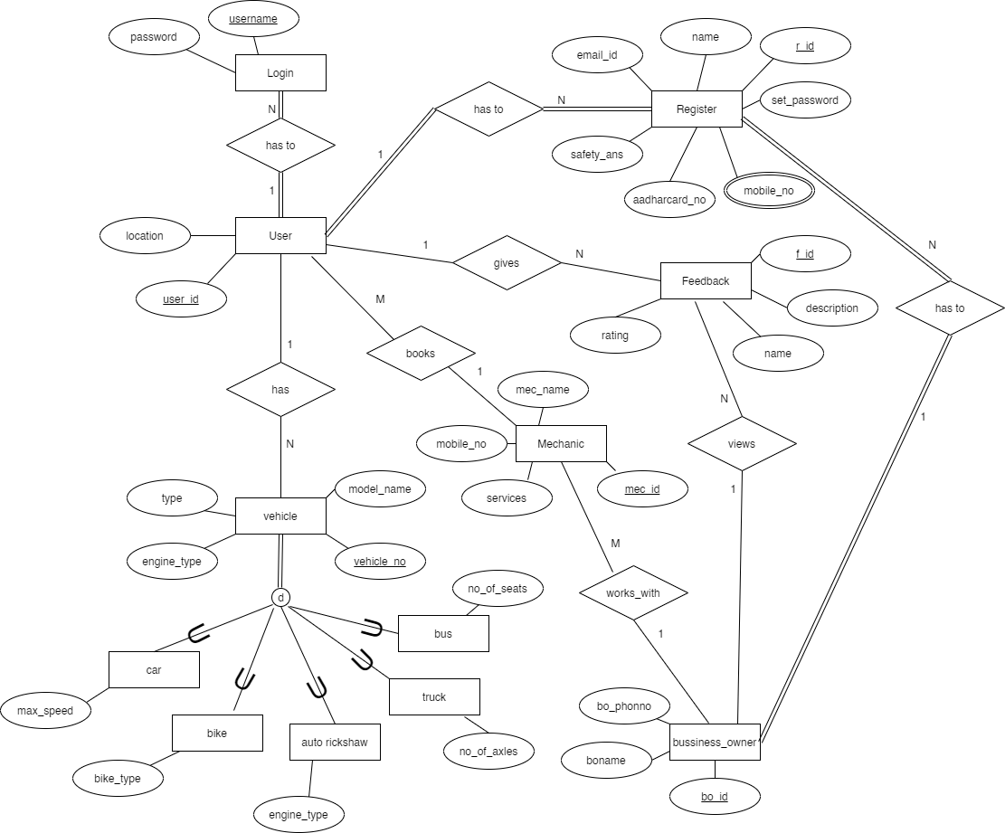

Process design:
The proposed system has two major divisions. One is the Owner dashboard and the other is the User Dashboard.
A. Owner Dashboard: The Owner Dashboard allows the mechanic to initially register into the system and after logging in the application, the Owner will be able to add a mechanic, delete a mechanic or view the feedback given by the user.
B. User Dashboard: The Customer dashboard mainly focuses on recording customer feedbacks, adding the vehicle details, entering the location for services and selecting nearby mechanics available in that locality.
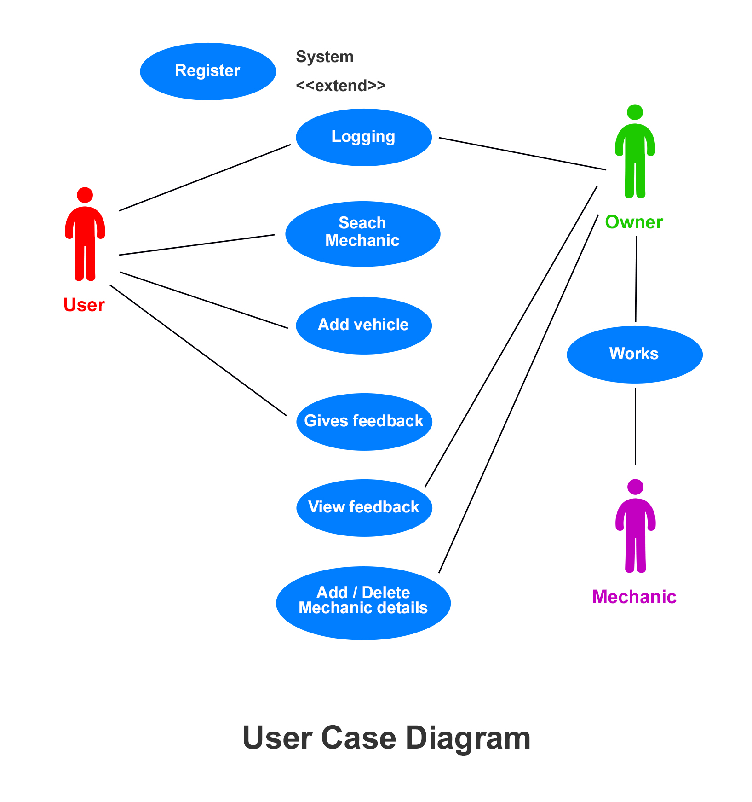
C. Working: The working starts from the user’s dashboard where a request will be lodged for the vehicle. Furthermore, the customer will be able to see the nearby mechanics in that locality by entering its location and call the mechanic. After the service has been done the user can provide a valuable feedback for the mechanic. In the owner dashboard, it will be able to add or delete its mechanic and view the feedback given by the user and hence improve the service of the mechanics working under him.
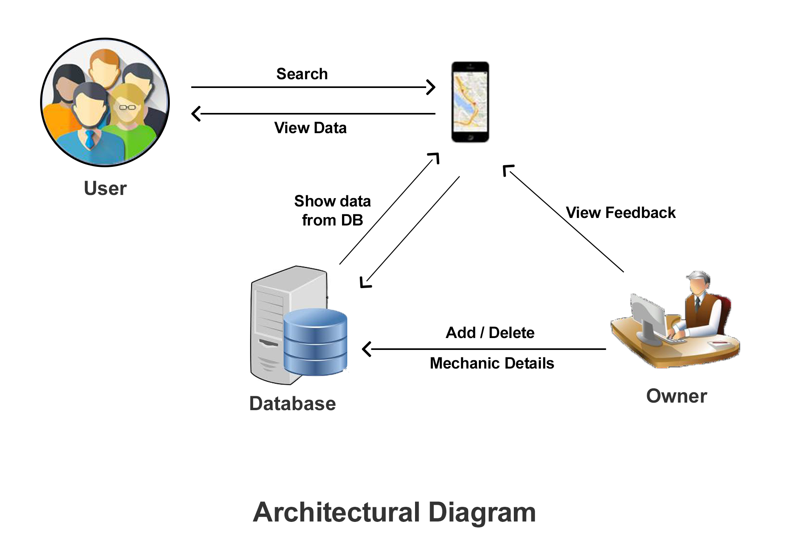

Details of hardware and software:
- Operating System: Windows 7 and above
- Language: JAVAFX
- Database: Postgresql
- IDE: Intellij
- Browser: Google Chrome

Experiment Results:
- Login Page:
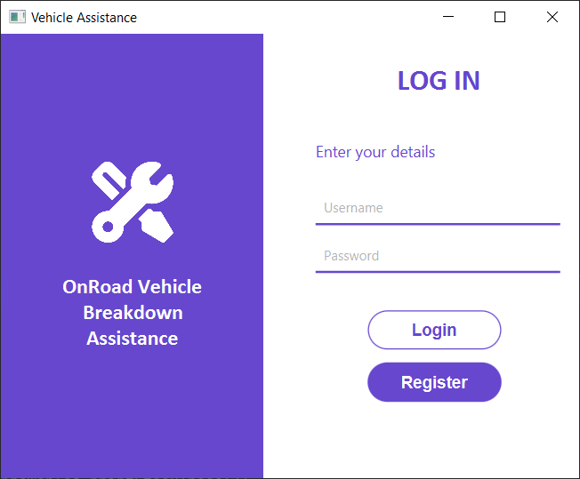
- Register Page:
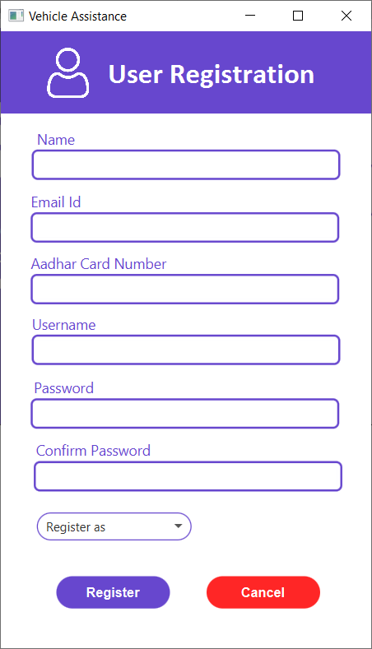

- User Dashboard
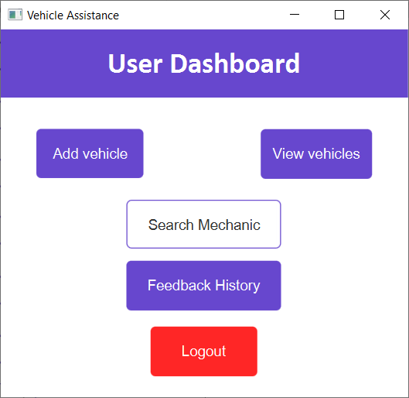

- Add Vehicle
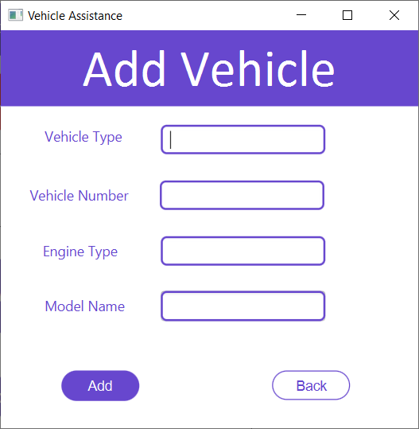
- Vehicles added by User.
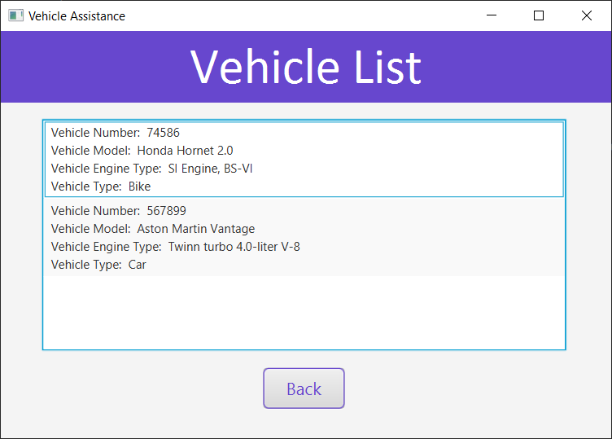

- Search Mechanic
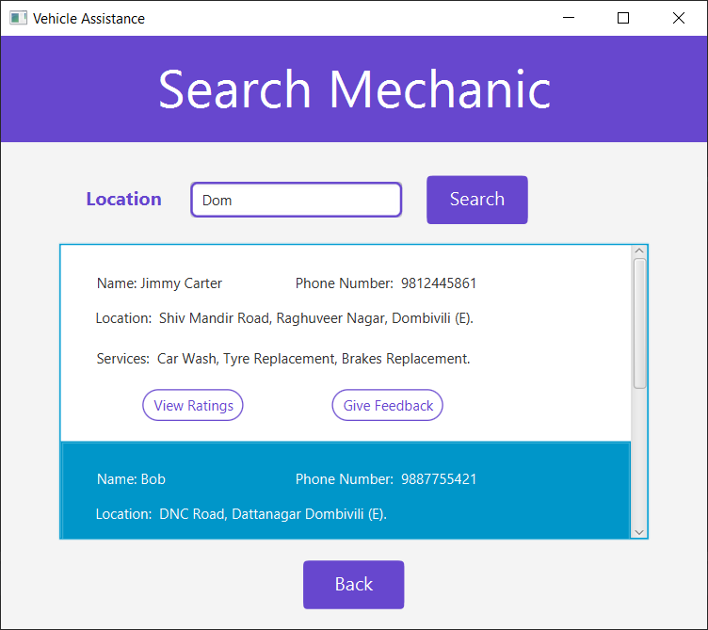

- View Rating
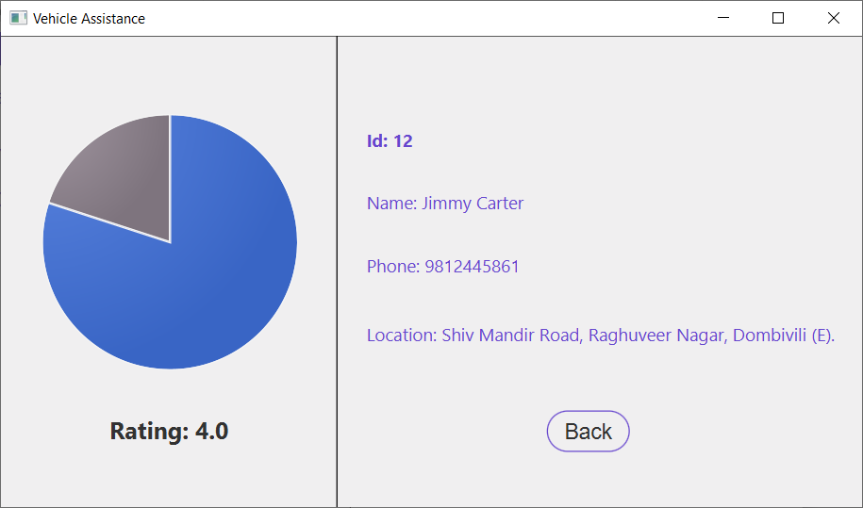

- Give Feedback
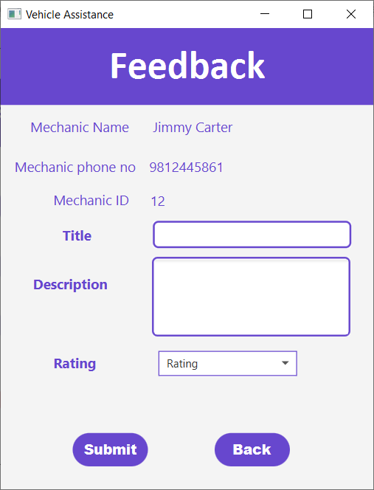

- View Previous Feedback (Given by User).
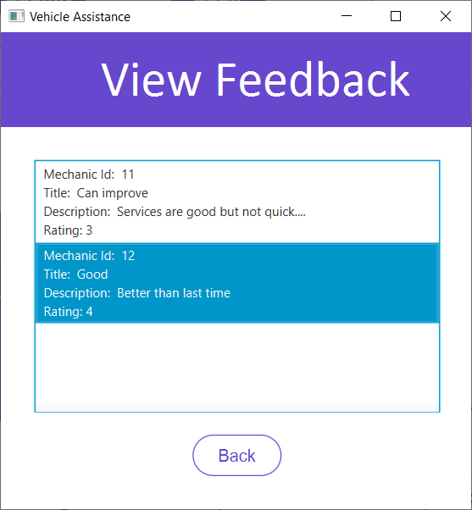
----------------------------XXXXXXXXXXXXXXXXXXXXXXXXXXXXXXXXX--------------------
1)Business Owner Dashboard
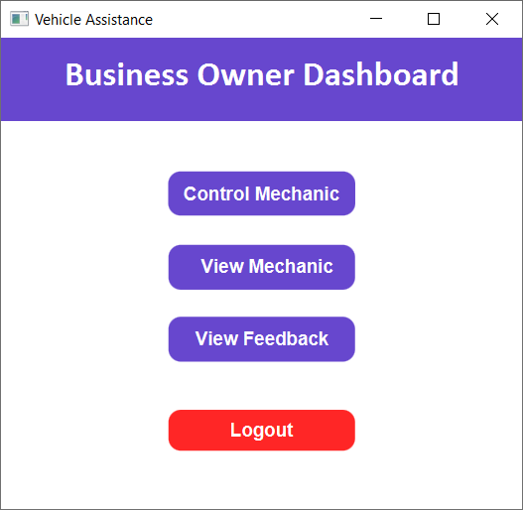
- Control mechanic( ADD or DELETE Mechanic Data)
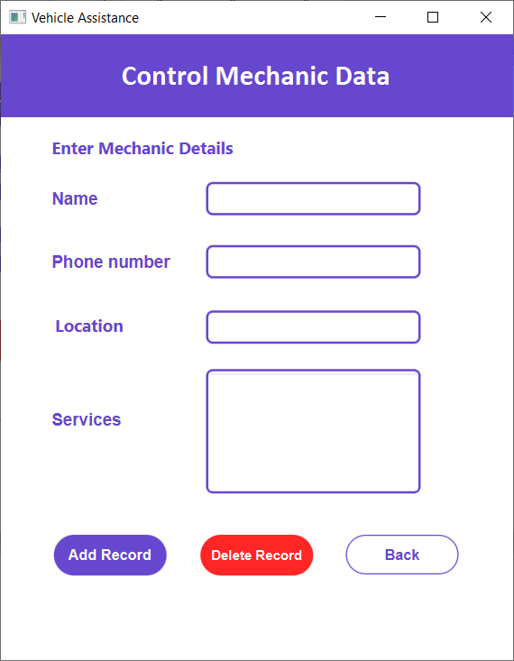
- View Added mechanics (Only added by a particular Owner).
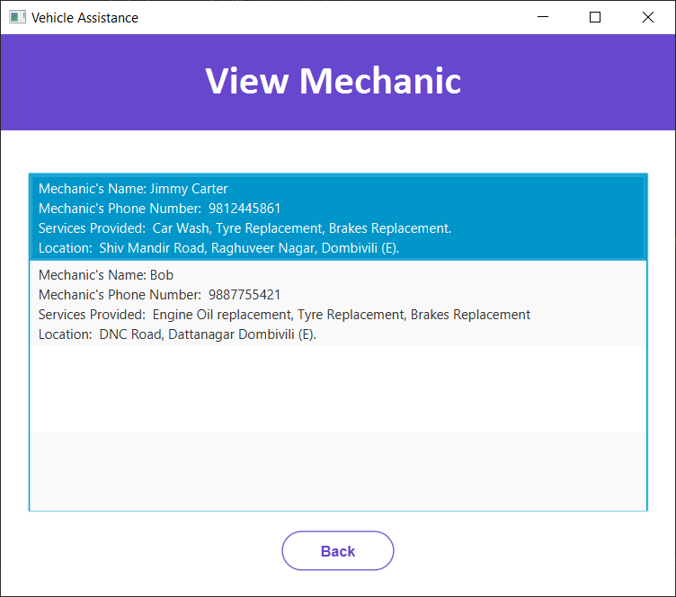
- View Feedback (Given to mechanics registered by him).
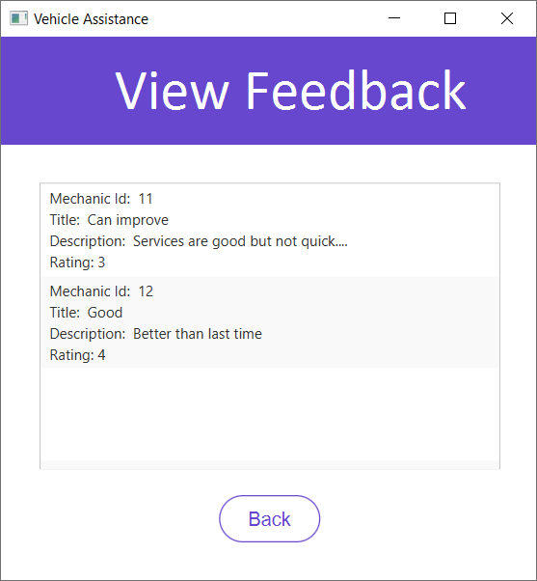

FUTURE WORK FOR SEM IV
The goal of this project is to produce an interactive application for the marketplace. A Mechanic Service is composed of two main components: a client-side application and a server-side application which will support and interact with various client-side features. The system is designed to provide, services provided by mechanics at various places, locations of all the service centers in the vicinity etc. The above proposed model is easy to implement considering the available technology infrastructure. The models are simple, secure and scalable. The proposed model is based on serial communication.
In in future development of the project there can be add the payment method for the project. That help to user do their vehicle repair in a reasonable price. This project can be further expanded and cooperate with insurance company. Then user able to claim the vehicle repair. That is big sedative for the user. We can also add a GPS system so that the user need not enter the location manually.

CONCLUSION
While the chances of a properly maintained vehicle experiencing a breakdown are slim, it is never a possibility to predict when the user may experience a vehicular breakdown. The application developed here promises to make the life of a vehicle owner that much easier, as even in the probability of a breakdown, the vehicle owner is assured of the fact that he has a solution to the problem within a few steps of entering details in his smart phone he can save himself from a major setback in such an undesirable situation. The proposed system promises to act as a source of protection against the unpredictability of a vehicular breakdown and offers the owner of a particular some peace of mind in the event of operational failure of the user’s vehicle.
In this Road Vehicle Breakdown Assistance System project in java and SQL, we presented the design and implementation of an application called On Road Vehicle Breakdown Assistance, with which users can get the mechanic’s details and help anytime on the desired location. The system provides information of mechanics based on the user’s location. The system is a combination of java and PostgreSQL and will help the user.

REFERENCES
- https://codeshoppy.com/shop/product/on-road-vehicle-breakdown-assistance-app/
- https://www.tutorialspoint.com/index.htm
- https://www.javatpoint.com
- https://patents.google.com/patent/US6972669B2/en
- https://www.youtube.com/watch?v=XAowXcmQ-kA&t=1693s

